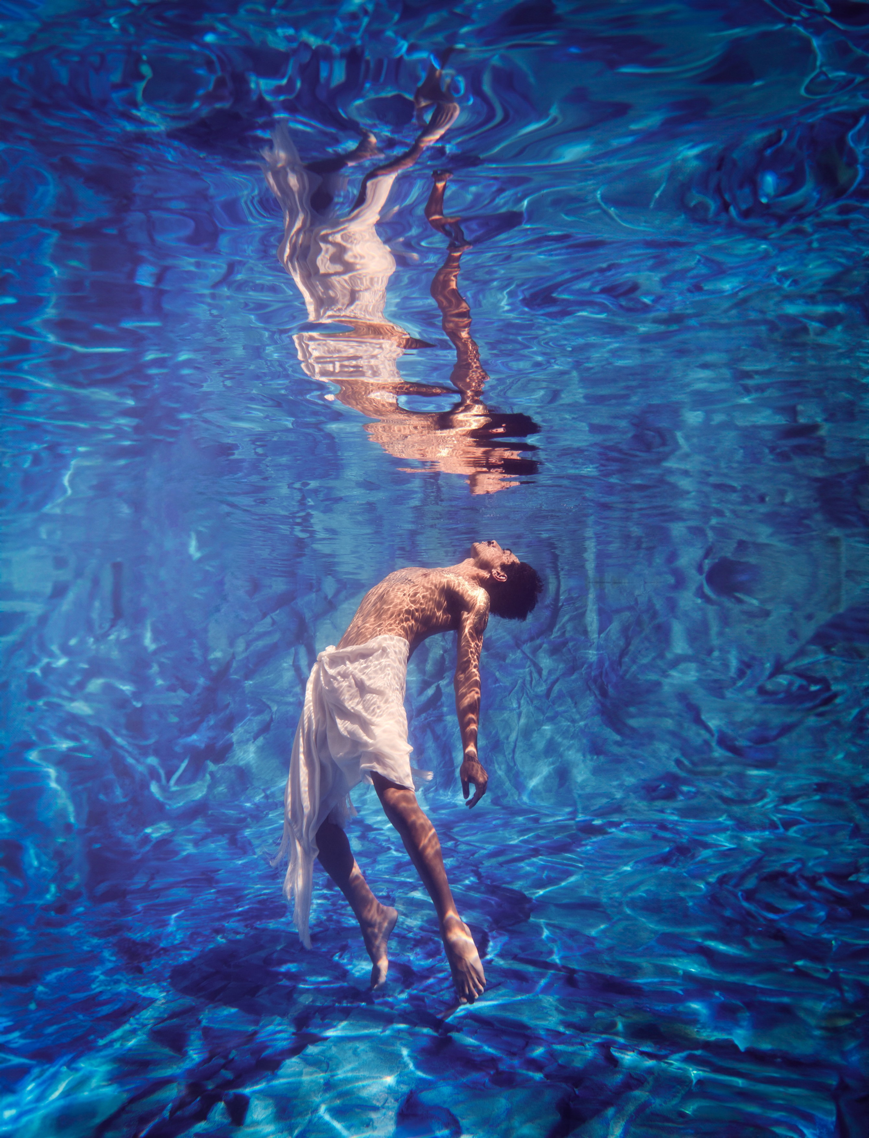

Image description: The image shows a male dancer suspended in bright blue water. His upper body is bare and is curved backwards, his legs and arms drift downwards. His refection is above him, so it looks like there are two bodies in the water facing each other. A piece of lightweight white fabric is loosely wrapped and tied around his waist, and drapes down to cover his thighs.
The Light Inside
Easy-Read program

ACKNOWLEDGEMENT
Bangarra Dance Theatre pays respect and acknowledges the Traditional Custodians of the Land which our Company calls home, the Gadigal People of the Eora Nation.

Acknowledgement means you understand that something is the truth, and that it is important.

Aboriginal and Torres Strait Islander readers are advised that this program contains the name of someone who has passed away.

This Easy-Read version of The Light Inside program is a summary of a larger The Light Inside program. You can find the larger program here or on our website.

About Bangarra Dance Theatre

Bangarra is a company of professional Aboriginal and Torres Strait Islander performers. We are storytellers. We are fire makers. We share our culture with Communities and audiences across Australia and the world, drawing on our 65,000 years of Culture.
Bangarra was founded in 1989 by American woman, Carole Y. Johnson. From 1991 to 2022, the company was led by creative director, Stephen Page. Today, Artistic Director and co-CEO Frances Rings and Executive Director and co-CEO Louise Ingram lead the company in our mission to promote awareness and understanding of our First Nations cultures.
Every year, we tour across the nation and sometimes overseas as well. We also perform in small venues in regional and remote places. We exist for the hundreds of First Nations Communities across Australia, and for anyone who wants to be a part of our story.
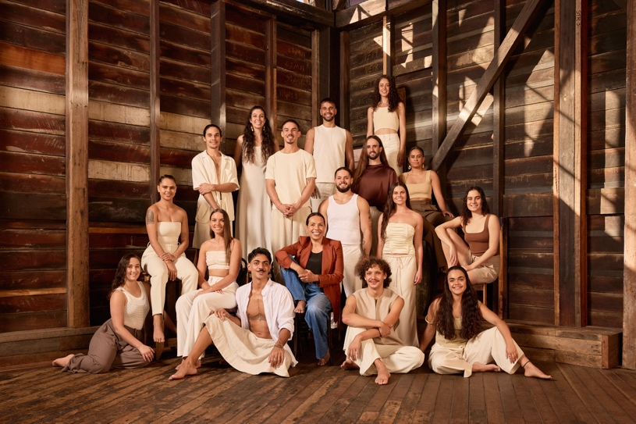
Image description: Group of sixteen Bangarra dancers, seven men and nine women, positioned at different heights, some sitting on the ground and other standing on pillars. They wear light-coloured casual clothes. In the middle is Artistic Director Frances Rings, who wear blue jeans and a rusty brown jacket. They are inside a large timber building.

The Light Inside tell stories about two special places – the Torres Strait and New Zealand - and the people who live there. The Light Inside was created in 2024.

Zenadth kes / Torres Strait flag
Image description: Horizontal panels at top and bottom of flag are green representing the land of Papua New Guinea and Australia. The blue panel in the middle represents the Torres Strait waters. In the centre is a white star with four points representing the five island groups. Around the star is a white semi-circle shape with pointy ends. This is the shape of a traditional head dress and represents the Culture.
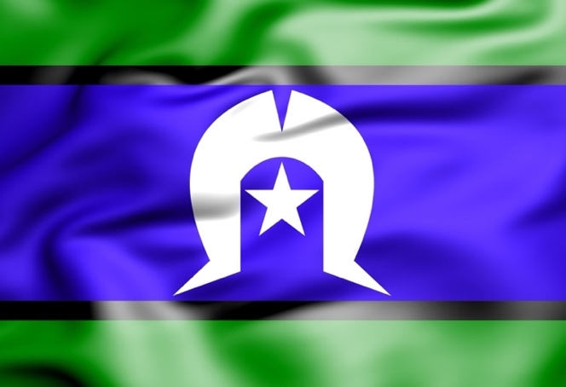

The Māori flag of Aotearoa/New Zealand

Image description:
Top section is black, bottom section is red. A white curved shape that cuts through the middle. This represents three realms: potential being (black); realm of light (red) The curved shape is the Koru, symbolising the curling fern frond to represent new life, hope for the future, and renewal.

The Light Inside
The Light Inside is a work in two parts. The first part is a saltwater story from Zenadth Kes / Torres Strait, choreographed by Deborah Brown, and the second part is a freshwater story from Aotearoa / New Zealand, choreographed by Moss Te Ururangi Patterson.

At the beginning of the saltwater story, we hear voices of ancestors calling out from the past. These are the voices of people who lived in the 1890s. Their recorded voices have been preserved in metal cylinders in the British Library. This is why they sound a bit crackly.
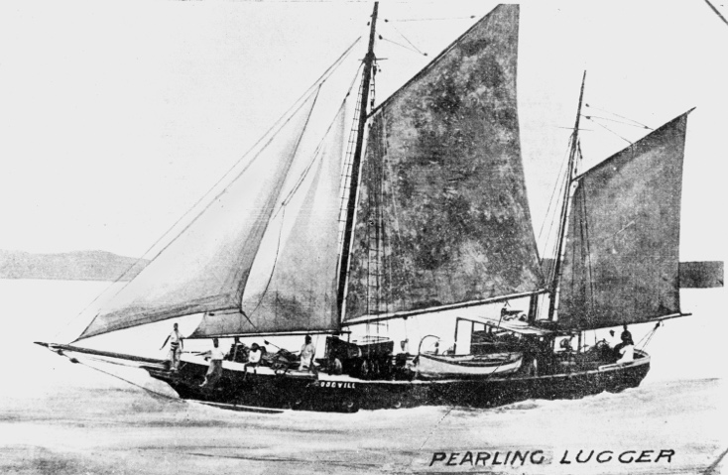 | This is followed by the story of the luggers. Luggers are boats that were used in the pearling industry. They were manned by divers who swam to the ocean floor to gather the pearl shells.
Image description: A pencil drawing of a timber lugger boat with a set of four sails – two large and two small. About seven people either sit or stand on the boat as it leans slightly to one side when sailing across water. A distant land is in the background.
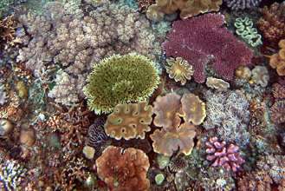 | The next section is Reef and is about the coral reefs, in the sea. Reefs are places of beauty and wonder, and a home for sea life. The coral feeds on organic material. Reefs can be millions of years old.
Image description: A patch of different corals in various colours and textures, attached to the seabed and to each other.

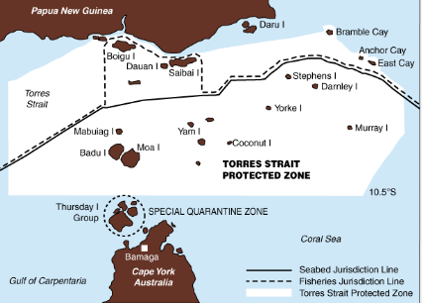 | Boundaries is the next section and is about the Treaty that was signed by Australia and Papua and New Guinea in the 1970s, to protect the Kinship connections and make sure people could travel around the islands and fish where they had always fished for thousands of years.
Image description: A map showing different boundaries in the Torres Strait. 1. The seabed boundary. 2. The fishing boundary. 3. The protected zone.

The blue star signals the change of season, and Tagai, the hunter is the star constellation that guides people to bring together.
Image description: White dots joined together by white lines on a black background to represent the shape of a man with arms, hands and legs stretched out. The image represents the hunter – Tagai.

At the beginning of the freshwater story is a dance that represents the godly state of Māori culture that reminds people to seek a higher form of wisdom.
The next section story tells of the journey the ancestors who came from Hawaii. During the journey they were pulled into a whirlpool but one of the ancestors called up the hammerhead shark to pull them out and guide them.
The arrival at lake Taupo is marked by the story of the hundred winds.
The dancers perform to a haka a traditional Maori song / dance. This haka calls for the government of New Zealand to honour the Treaty of Waitangi which is the agreement white settlers and Maori chiefs signed in 1840.
The next section is about the resilience of the people and acknowledges the female spiritual warrior the hawk, who leads people into the future.
The next part of the dance is based on the stories of the sacredness of hair. One story is that of a sister who gives her brother a strand of her hair which carries the knowledge, strength, and courage to tame the sun. The other story is about the power of women and the three baskets of knowledge that are passed down to humankind.
The final section is about the cleansing and purification of the soul.

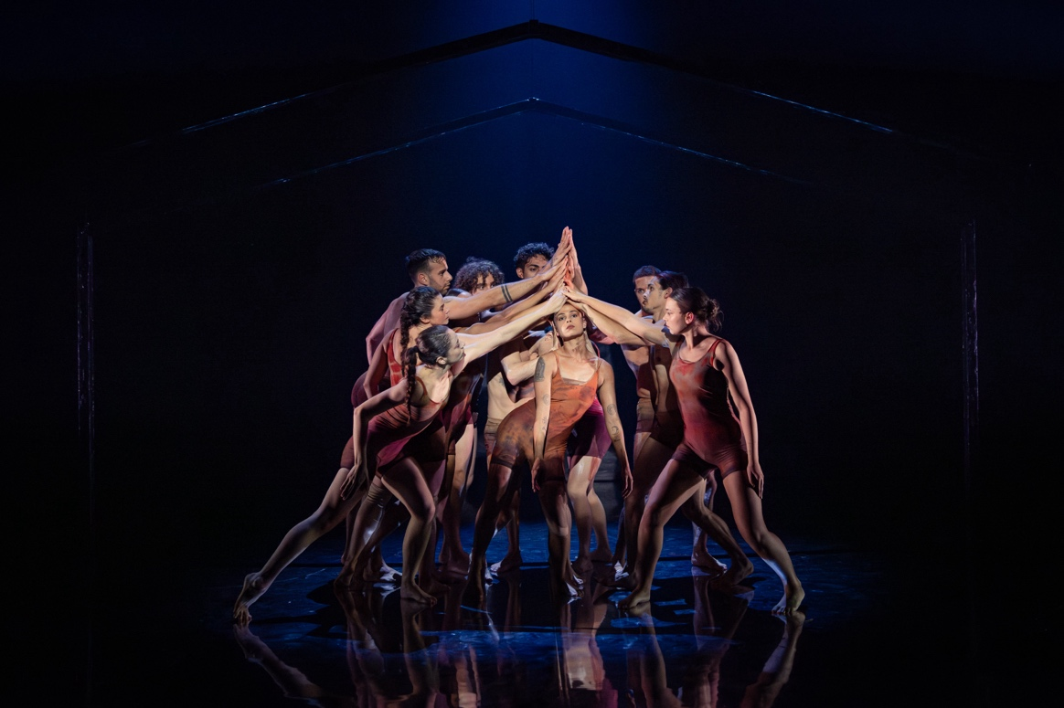
Image description: a group of eight dancers dressed in muted red and orange shoulder to thigh leotards. One woman in the centre. Her torso over one bent leg the other hip extends to the opposite direction. Her arms drop down beside her body. The other dancers around her in a semi-circle, they each place one hand pointed upwards to create a steeple of hands of top of her head. She represents the feminine spiritual hawk.

Image description: a group of fourteen dancers are illuminated in three strong shafts of light.

The Creative Team

The creative team is a group of people who create the productions that tell the stories. The team includes the people who choreograph the dance, make the music that the audience will hear, design what the stage will look like, decide what lights to use and design the costumes that the dancers wear.

The dancers work with the choreographer in the dance studio for many weeks to find the dance movements that will tell the story.

There are many other people on the creative team. The Rehearsal Director is in charge of practicing the movements each day with the dancers. Cultural Consultants also help create the work. Cultural Consultants are Aboriginal and/or Torres Strait Islander people who share their expert knowledge with the choreographer and the dancers.

These are the people in The Light Inside creative team:
 | Moss Paterson  Deborah Brown | Co-Choreographer, Cultural Advisor and Creative Collaborator of  The Light Inside  Co-choreographer of  The Light Inside
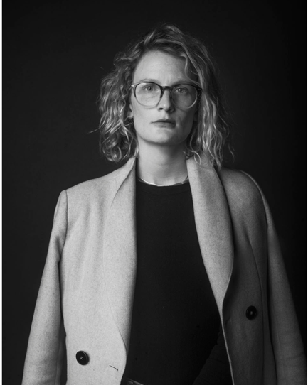 | Elizabeth Gadsby | Set Designer
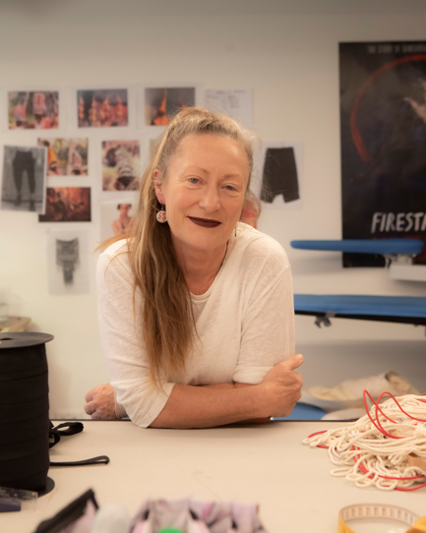 | Jennifer Irwin | Costume Designer
 | Karen Norris | Lighting Designer
 | Steve Francis | Composer
 | Shana O’Brien  Rikki Mason | Associate Set Designer  Rehearsal Director

These are the dancers who perform in the show. As well as their name, their cultural background is written. All the dancers at Bangarra are from Aboriginal and/or Torres Strait Islander background and are wearing pale brown and white loose clothing and are standing in front of a timber wall.

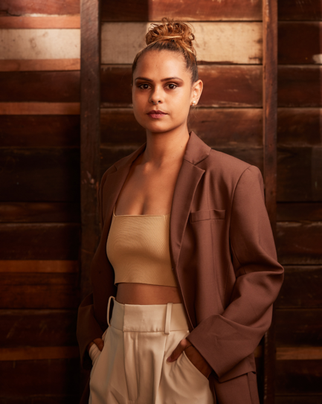 | Lillian Banks | A proud Yawuru woman from Broome, Western Australia.
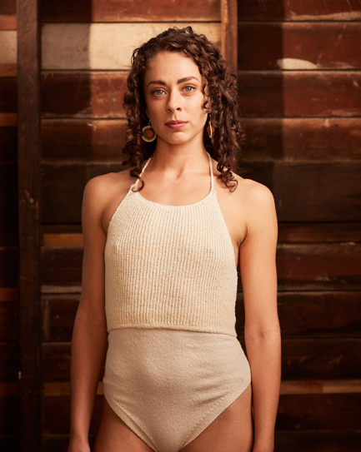 | Courtney Radford | Balardong descendant from Western Australia.
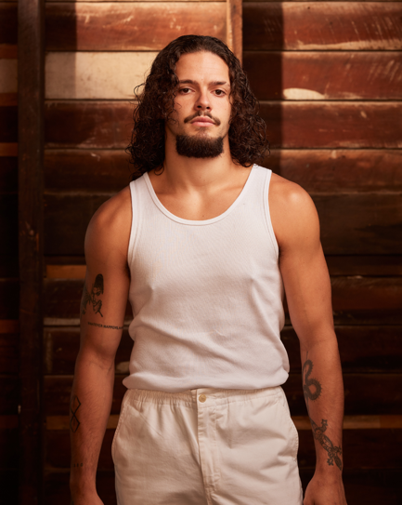 | Kallum Goolagong | A proud Wiradjuri and Darkinjung man from New South Wales.
 | Kassidy Waters | Wanaruah descendant from New South Wales.
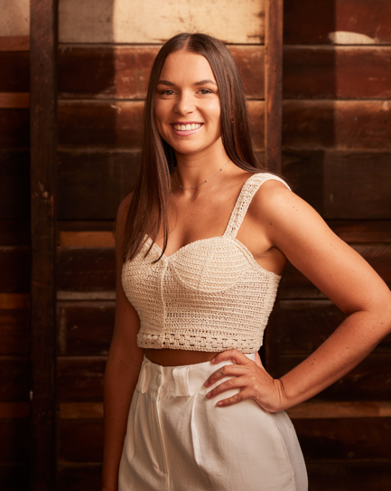 | Maddison Paluch | Wiradjuri descendant from New South Wales.
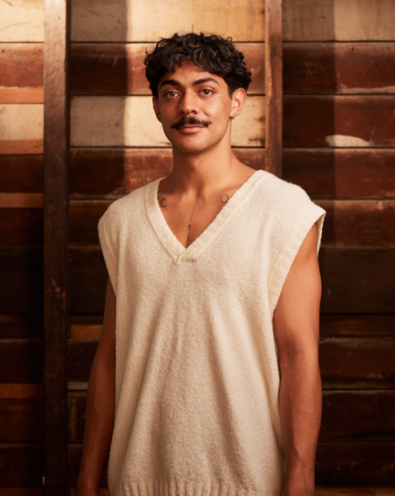 | Daniel Mateo | Gamilaroi descendant from New South Wales.
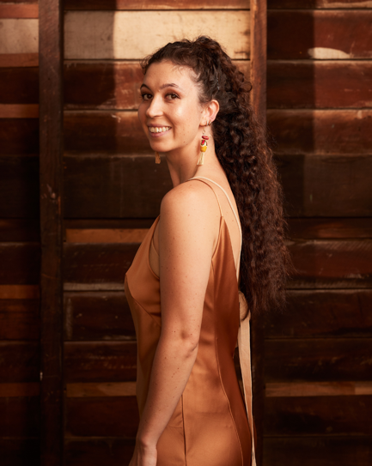 | Emily Flannery | A proud Wiradjuri woman from New South Wales.
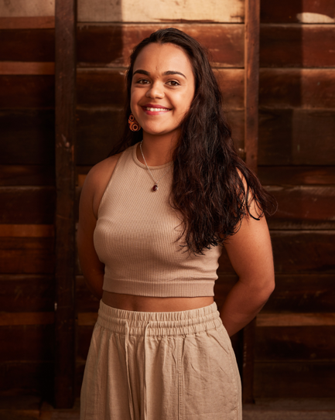 | Janaya Lamb | Wiradjuri and Torres Strait descendant from New South Wales.
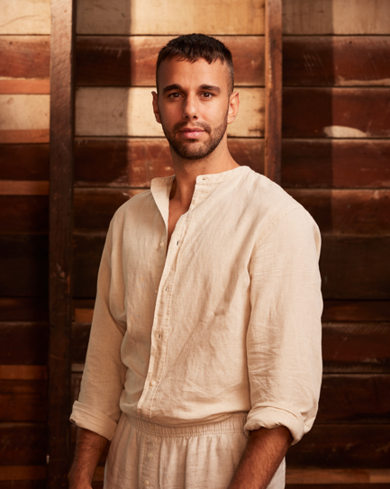 | James Boyd | A proud Aboriginal man with connections to Kunja and Muruwari people and Wakka Wakka Nation from New South Wales and Queensland.
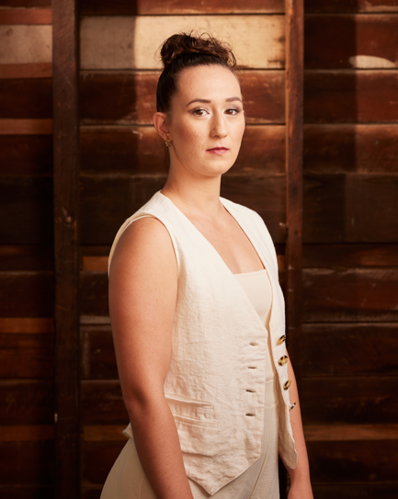 | Chantelle Lee Lockhart | Dharawal and Eora descendant from New South Wales.
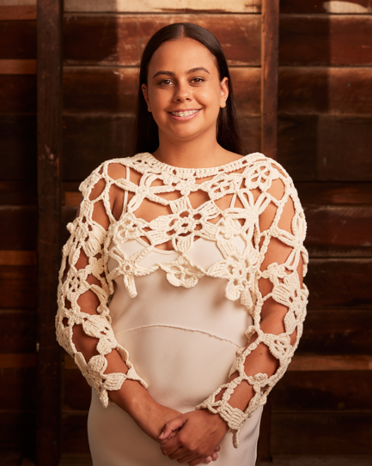 | Amberlilly Gordon | A proud Wiradjuri and Ngemba woman from New South Wales.
 | Donta Whitham  Jye Uren  Roxie Syron  Zeak Tass  Edan Porter  Eli Clarke | A descendant of the South Sea Islands with Ambrym Island connections on his mother’s side and Sri Lanka background on his father’s side.  A proud descendent of the Worimi and Dunghutti peoples and holds lineage to Biripi and Yorta Yorta Country.  A proud descendant of the Biripi and Worimi Nations of the Mid North Coast in NSW.  Zeak is a South Sea Islander and Yuwibara man from Mackay, Queensland  Edan is a proud Gomeroi man from North-West NSW.  A proud Arabana and Gurindji performer from Alice Springs NT.

Dancer Headshots by Daniel Boud. Promotional image by Daniel Boud.
Bangarra Dance Theatre
Gadigal Country, Eora Nation
Wharf 4/5, 15 Hickson road
Walsh bay NSW 2000
Phone +61 9251 5333
Email bangarra@bangarra.com.au

www.bangarra.com.au

 @bangarradancetheatre #bangarra
/bangarra
 /bangarradancetheatre

